

* **What are REST Webservices:**

**Business Problem:**

Suppose we are building a client app that provides the weather report for a city

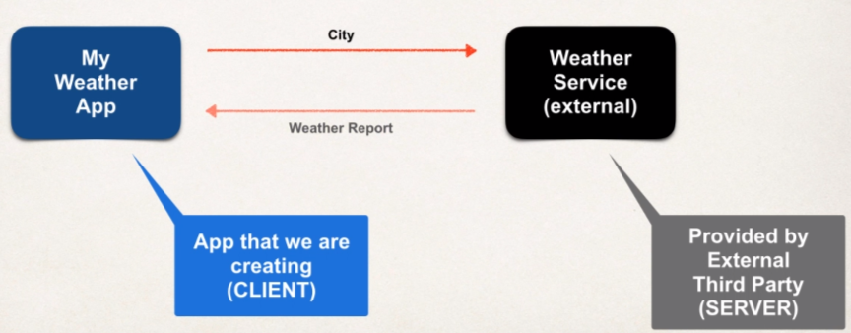Need to get weather data from an external service.

**How will we connect to the weather service?**

* We can make REST API calls over HTTP.
* REST: **RE**presentational **S**tate **T**ransfer.
* Light weight approach for communication between applications.

**What programming language do we use?**

* REST is language independent.
* The client application can use **ANY** programming language.
* The server application can use **ANY** programming language.

**What is the data format?**

* REST Applications can use any data format.
* Commonly see XML and JSON
* JSON is most popular and modern
* **J**ava**S**cript **O**bject **N**otation

**Possible Solution:**

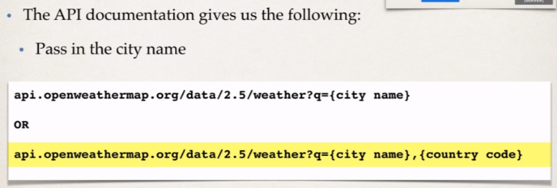Use free Weather service provided by: [openweathermap.org](https://openweathermap.org/)

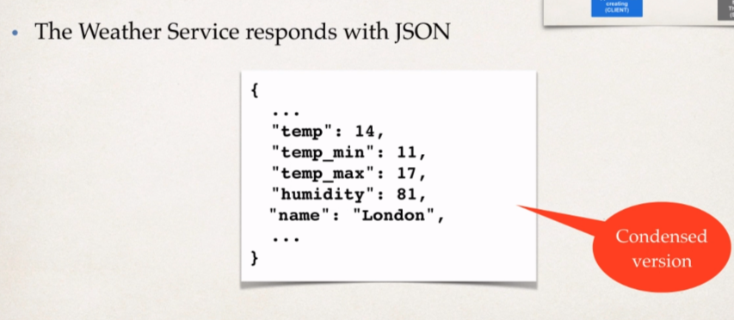

Nice thing about this approach of REST API REST Webservice:

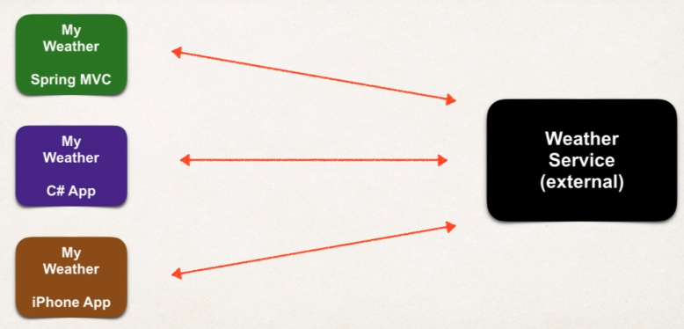There can be multiple type of clients that can access Weather service developed by the group weathermap.

**Remember:**

* REST calls can be made over HTTP.
* REST is language independent.

So, it gives us flexibility on actual implementation language.

**Another example**

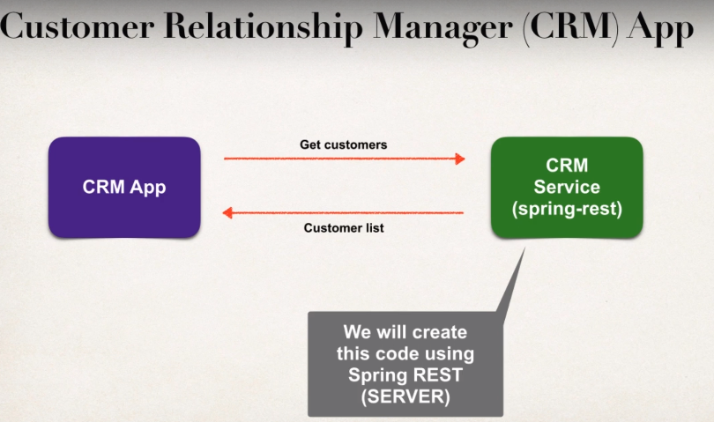In this course, we are going to create CRM Service than can pass customer data as JSON.

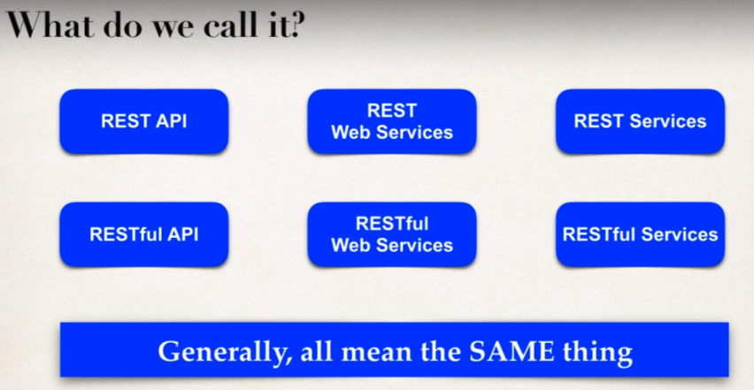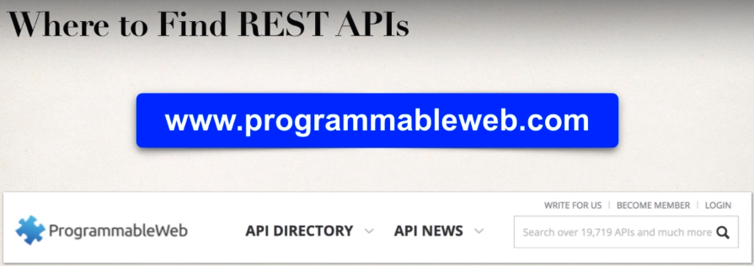

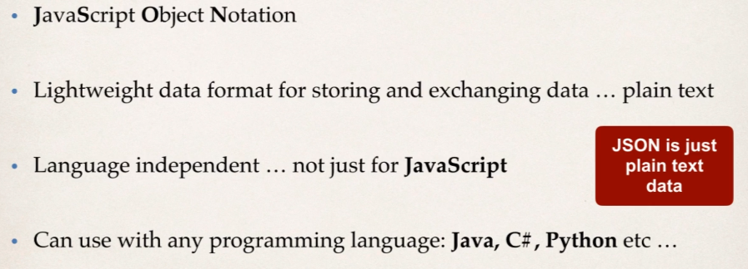**What is JSON?**

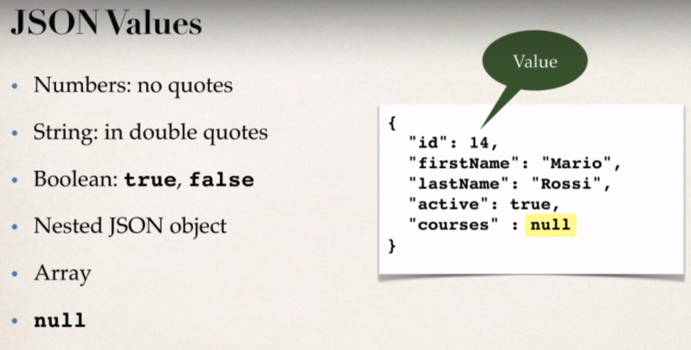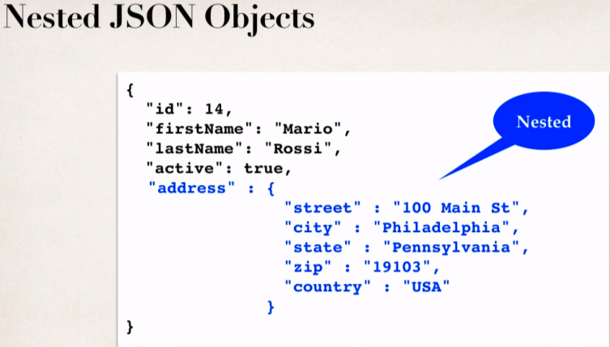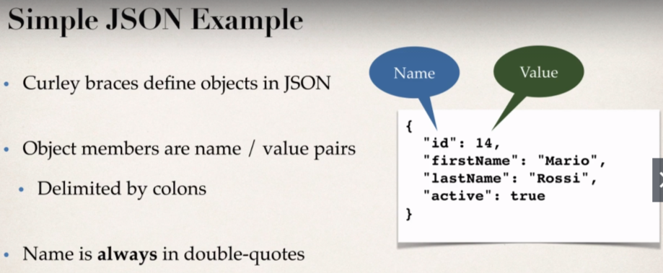

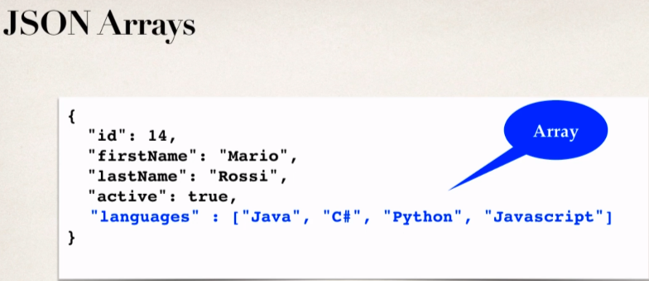

* **Java JSON Data Binding**
* Data binding is a process of converting JSON data to a Java POJO.

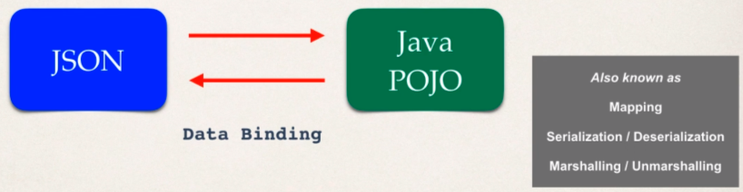So, it will read the JSON file or data and populate the Java object with that given data or we can start with Java POJO and then send it to a JSON file or JSON Data.

**JSON Data Binding with Jackson**

* Spring uses the **Jackson Project** behind the scenes
* Jackson Handles data binding between JSON and Java POJO.

(Jackson is a separation project for Data Binding and they have support for doing data binding in XML and in JSON)

**Details in Jackson Project:**

[htttps://github.com/FasterXML/Jackson-databind](https://github.com/FasterXML/jackson-databind)

**Jackson Data Binding API**:

Package: **com.fasterxml.jackson.databind**

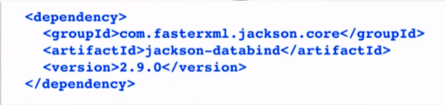**Maven Dependency**:

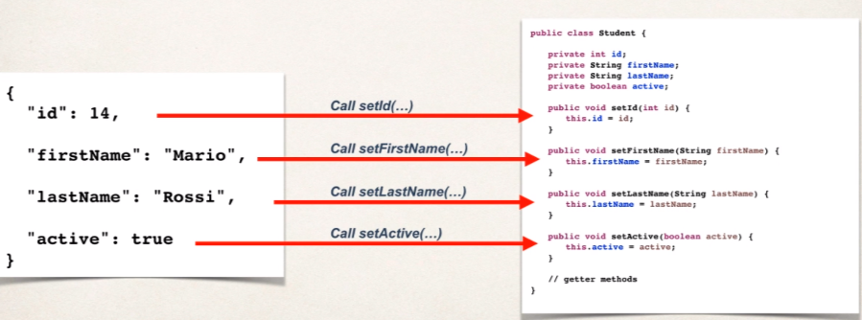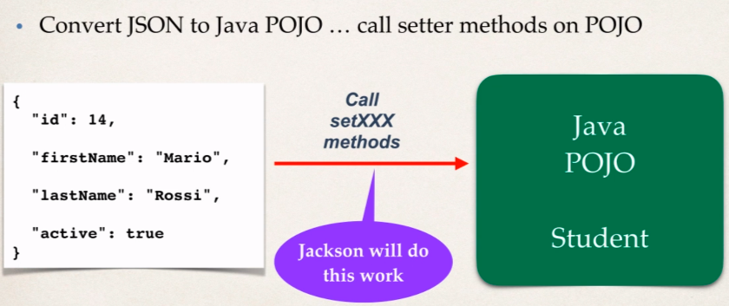By Default, Jackson will call appropriate getter/setter methods when it handles the conversion i.e., when it is converting from JSON to POJO then it calls setter methods and vice versa.

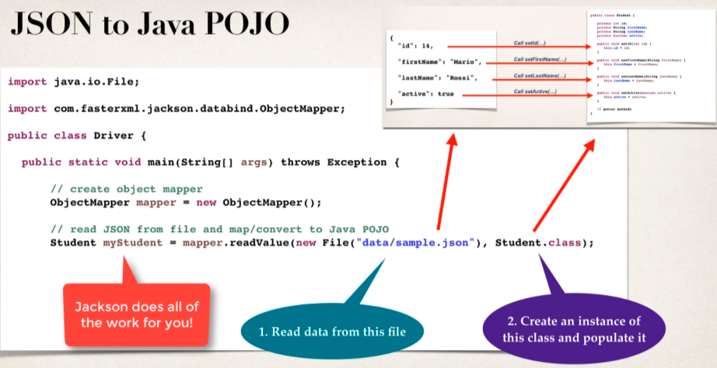

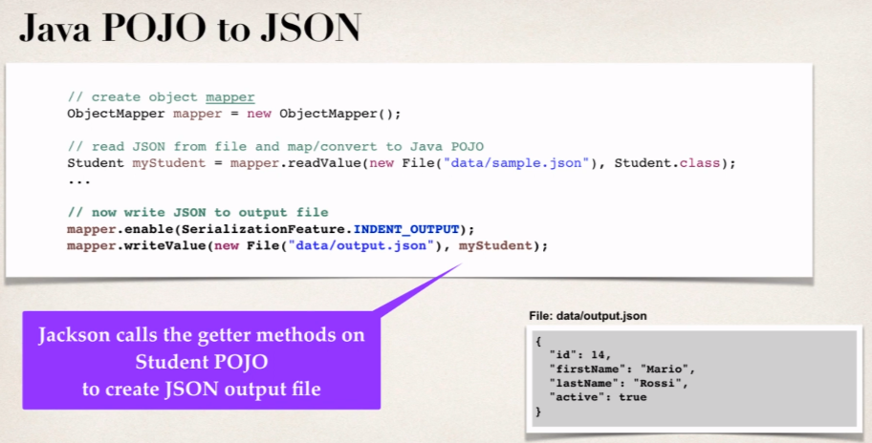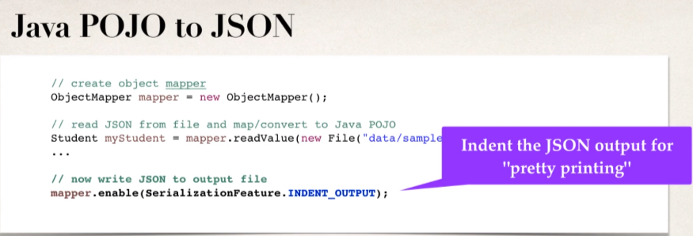

**Spring and Jackson Support:**

When building Spring REST applications;

* Spring will automatically handle Jackson Integration
* JSON data being passed to REST controller is converted to POJO
* Java object being returned from REST controller is converted to JSON automatically.

**JSON Jackson Demo – Set up Maven Project:** [Java Project Link](https://github.com/000GEV744/Spring-Git/tree/main/jackson-databinding-json-demo)

Here is [link](https://github.com/000GEV744/Spring-Git/tree/main/jackson-databinding-json-demo) for starter project, import it into eclipse and give location to the folder where we have pom.xml file.

Then go to pom.xml file and add the dependency:

<dependency>

<groupId>com.fasterxml.jackson.core</groupId>

<artifactId>jackson-databind</artifactId>

<version>2.12.3</version>

</dependency>

Create the Student class: [Student.java](https://github.com/000GEV744/Spring-Git/blob/main/jackson-databinding-json-demo/src/main/java/com/luv2code/jackson/json/demo/Student.java)

**public** **class** Student {

**private** **int** id;

**private** String firstName;

**private** String lastName;

**private** **boolean** active;

**// default constructor and getters/setters**

}

Create the Driver class which will contain the main() method: [Driver.java](https://github.com/000GEV744/Spring-Git/blob/main/jackson-databinding-json-demo/src/main/java/com/luv2code/jackson/json/demo/Driver.java)

**package** com.luv2code.jackson.json.demo;

**import** java.io.File;

**import** com.fasterxml.jackson.databind.ObjectMapper;

**public** **class** Driver {

**public** **static** **void** main(String[] args) {

**try** {

//create object mapper

ObjectMapper mapper = **new** ObjectMapper();

//read JOSN file and map/convert to Java POJO

//data/sample-lite.json

Student theStudent = mapper.readValue(

**new** File("data/sample-lite.json"),Student.**class**);

//print first name and last name

System.***out***.println("First Name: "+theStudent.getFirstName());

System.***out***.println("First Name: "+theStudent.getLastName());

}**catch** (Exception e) {

e.printStackTrace();

}

}

}

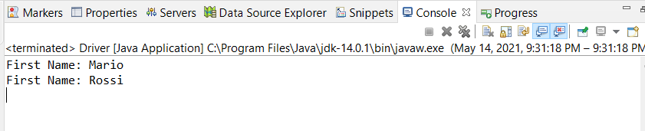**Output:**

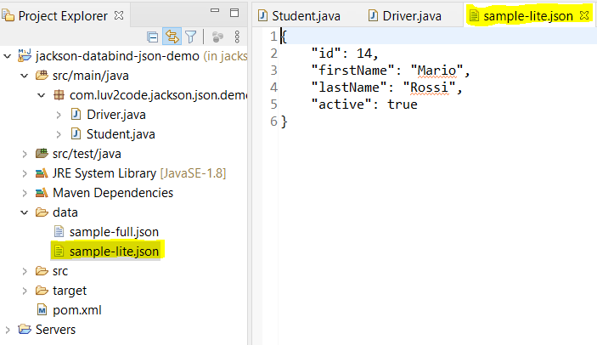And here is JSON file inside the **data** folder:

* **JSON Jackson Demo -Nested Objects and Arrays:**

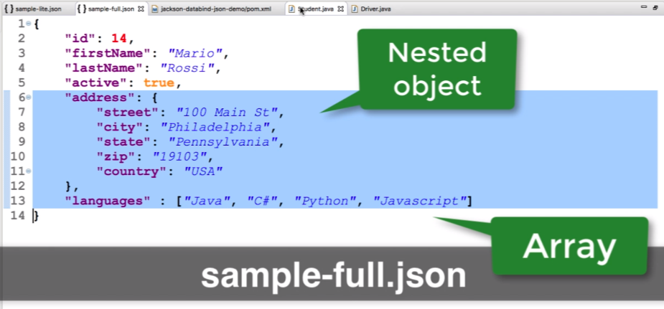File”: [sample-full.json](https://github.com/000GEV744/Spring-Git/blob/main/jackson-databinding-json-demo/data/sample-full.json)

Now we need to create a new Student class where we should have extra setter methods for fields like languages and address otherwise Jackson will throw error.

**File:** [Address.java](https://github.com/000GEV744/Spring-Git/blob/main/jackson-databinding-json-demo/src/main/java/com/luv2code/jackson/json/demo/Address.java)

**package** com.luv2code.jackson.json.demo;

**public** **class** Address {

**private** String street;

**private** String city;

**private** String state;

**private** String zip;

**private** String country;

//getters/setters

@Override

**public** String toString() {

**return** "Address [street=" + street + ", city=" + city + ", state=" + state + ", zip=" + zip + ", country="+ country + "]";

}

}

File: [DriverFullJSON.java](https://github.com/000GEV744/Spring-Git/blob/main/jackson-databinding-json-demo/src/main/java/com/luv2code/jackson/json/demo/DriverFullJSON.java)

//create object mapper

ObjectMapper mapper = **new** ObjectMapper();

//read JOSN file and map/convert to Java POJO

//data/sample-lite.json

Student theStudent =

mapper.readValue(

**new** File("data/sample-full.json"),

Student.**class**);

//print first name and last name

System.***out***.println("First Name: "+theStudent.getFirstName());

System.***out***.println("First Name: "+theStudent.getLastName());

//print out address: street and city

Address tempAddress = theStudent.getAddress();

System.***out***.println("Street: "+tempAddress.getState());

System.***out***.println("City: "+tempAddress.getCity());

//print out languages

**for**(String tempLang : theStudent.getLanguages()) {

System.***out***.println(tempLang);

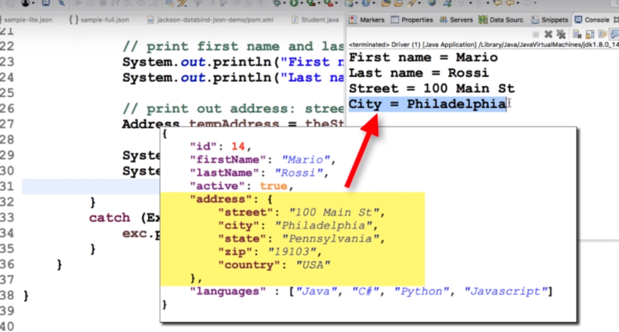**Output:**

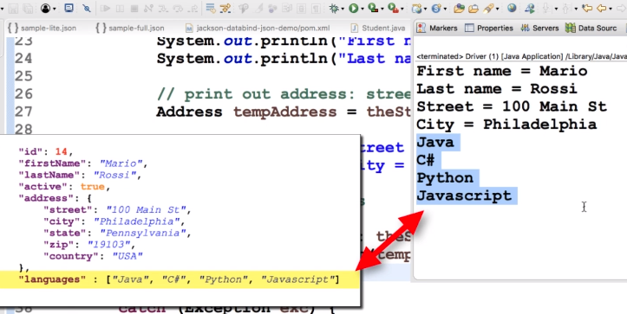

If JSON has property that we don’t care about….

Wouldn’t it be great to ignore it?

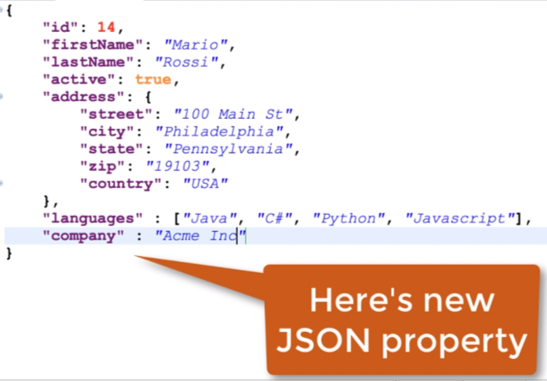**Use Case**

A new property is added to JSON our code is not aware of it…it can cause exception like we saw in previous section.

In this case, we will modify our code to “**ignore**” unknown properties.

Now, this new property under normal circumstances will cause our application to fail, so we just want to work around with that property in our application.

**Error that we will get:**

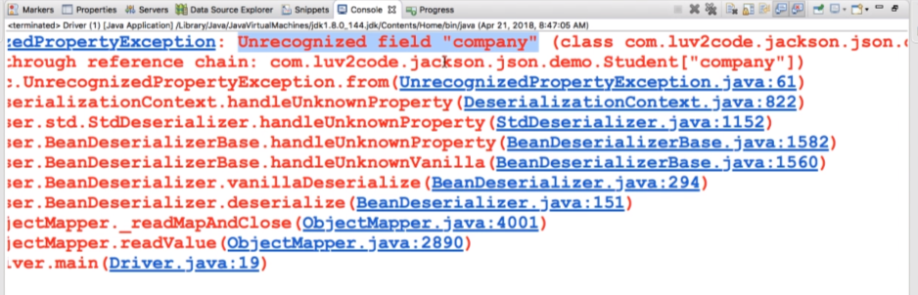

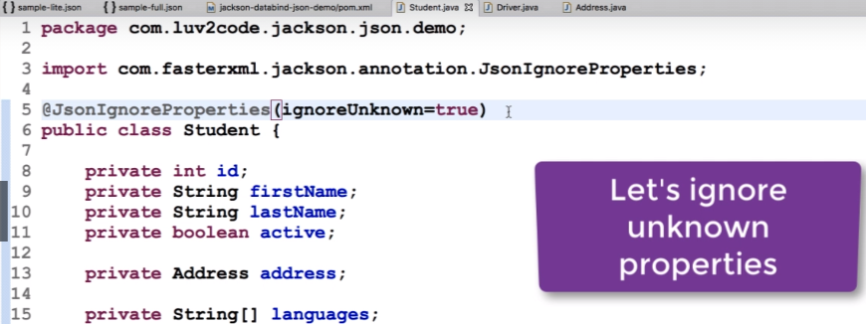So, we will make use of a special annotation ***@JsonIgnoreProperties(ignoreUnknown=true)***

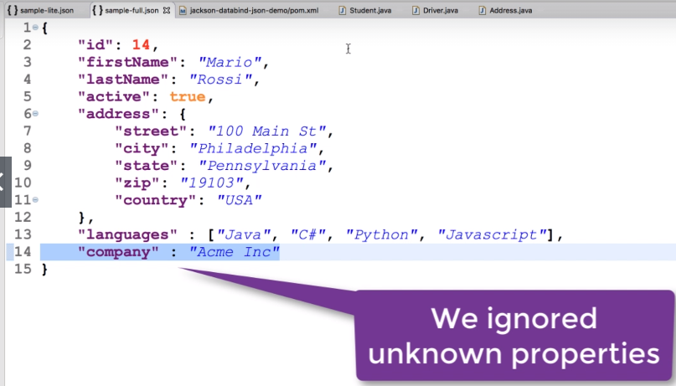

So based on that annotation we are ignoring the **company** property, since this property is not present in our **Student** class.



* **REST HTTP Basics**
* Most common use of REST is over HTTP.
* 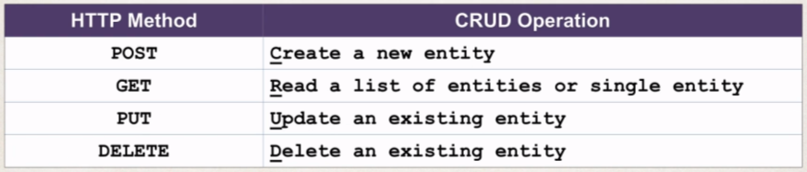Leverage HTTP methods for CRUD operations.

**HTTP Messages:**

In our example of CRM REST Services;

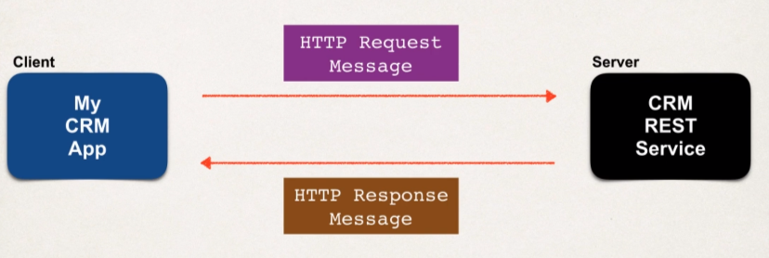We have our CRM Client which will send over REST Request to a server or CRM REST Service.

Let’s break down what’s inside HTTP Request message and in HTTP response message.

**HTTP Request Message:**

The Actual request message has three main parts:

1. Request Line
2. Header Variables
3. Message Body

**Request line:** it has the actual HTTP command or method (like GET, POST, DELETE method)

**Header variable:** it has the request Metadata, so additional information about this request.

**Message Body:** It has the actual contents of the message or the payload.

**HTTP Response Message:**

It also has three main parts:

1. Response Line
2. Header Variables
3. Message Body

**Response Line:** It has the actual server protocol and the status code (like 200, 404, 500).

**Header Variables:** it has response metadata; it has the actual information about the data (like content type of the data i.e., XML or JSON and the size and length of the data)

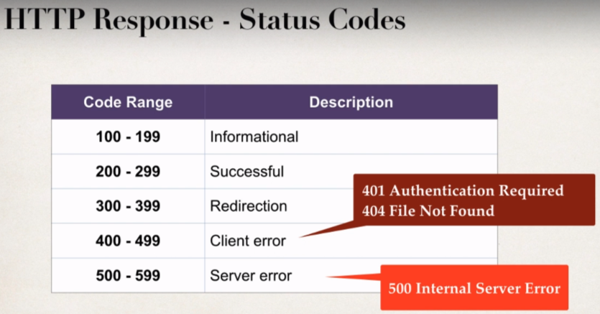**Message Body:** It contains the contents of the message, like if we say give me the list of customers then that customer list will actually come into the Message Body either in XML or JSON.

**MIME Content Type:**

* This is basically the message format for the actual payload.
* MIME stands for **M**ultipurpose **I**nternet **M**ail-**E**xtension.
* Basic syntax: type/sub-type
* Examples: text/html, text/plain

So, this is the information turn back to the client and then client can render it accordingly. In the examples above,

If we return back ***text/html*** to a web browser, then the web browser will render that based on the HTML tags.

If we pass back ***text/plain***, the web browser will simply juts show you the plain text in the browser.

In particular, for RESTful clients, you can pass back ***application/json***, so we can tell the client that we are returning JSON data for you or we can have ***application/xml***, saying this content coming back is XML.

**Spring REST controller:**

* Spring Web MVC provides support for Spring REST.
* New annotation **@RestController**
* Extension of @Controller that we use in regular spring MVC development.
* But @RestController have the support for REST requests and responses.
* So, Spring REST will also automatically convert Java POJOs to JSON
* i.e., As long as Jackson project is on the classpath or pom.xml, spring REST will handle this conversion for us automatically.

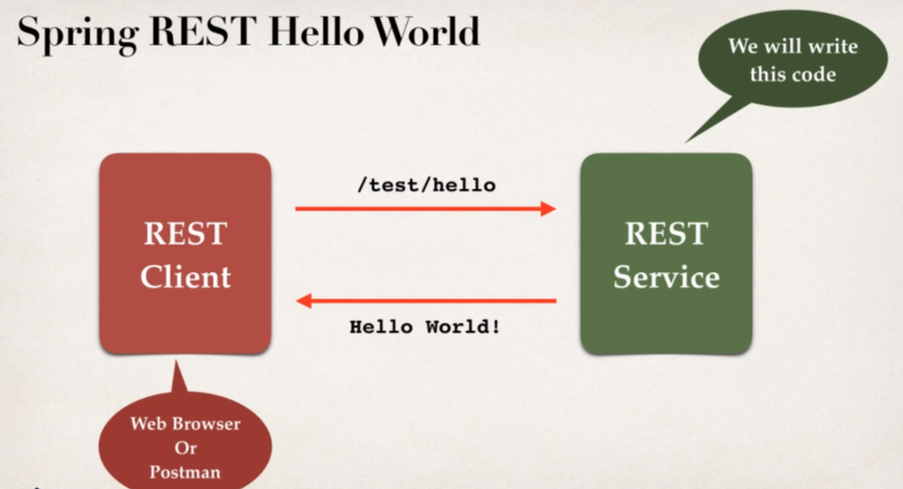**Spring REST Hello world Example:** [Java Project Link](https://github.com/000GEV744/Spring-Git/tree/main/spring-rest-demo)

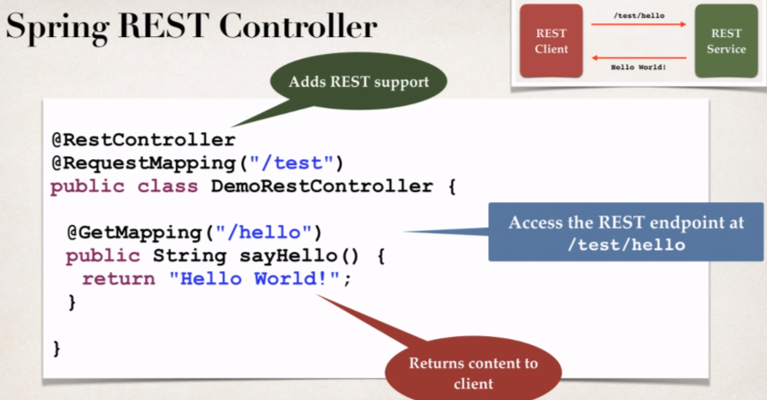**Spring REST Controller:**

**Spring REST Controller Development Process:**

1. Add Maven Dependency for Spring MVC and Jackson project.

* Add support for **spring-webmvc** as it also has support for **REST**.
* Also, we need to add the Jackson support for POJO to JOSN conversion.
* 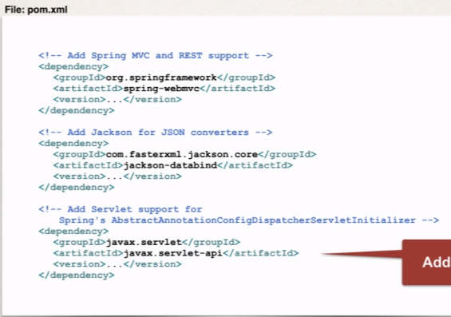And we need to add Servlet support because when we do all Java configuration then spring dispatcher servlet initializer depends on the servlet API.

1. Add code for All Java Config: @Configuration

* 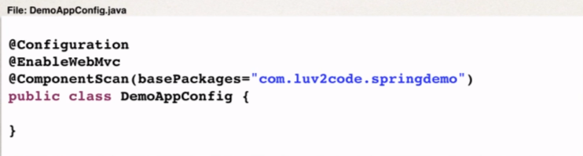We need to add **@Configuration, @ComponentScan(BasePackages=””),** **@EnableWebMvc** annotation.

1. Add code for All java config: Servlet Initializer.

* Spring MVC provides support for web app initialization.
* Makes sure your code is automatically detected.
* Your code is used to initialize the servlet container.
* And we will make use of the class **AbstractAnnotationConfigDispatcherServletInitializer**.

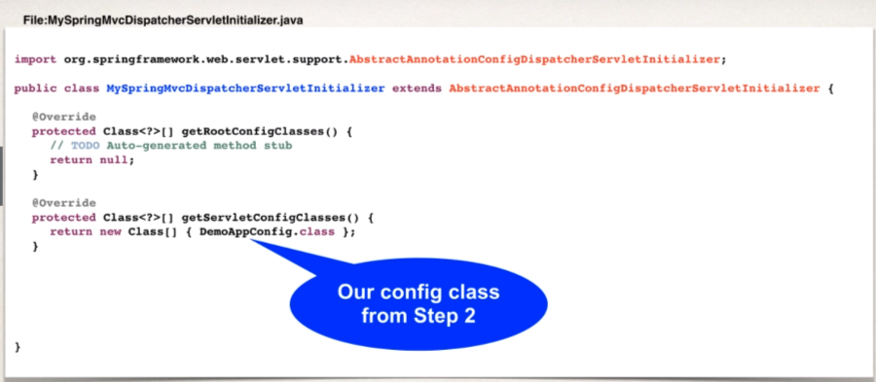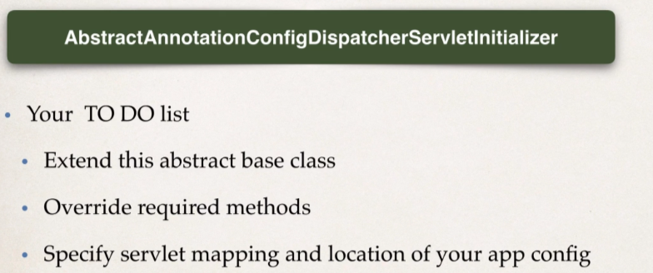

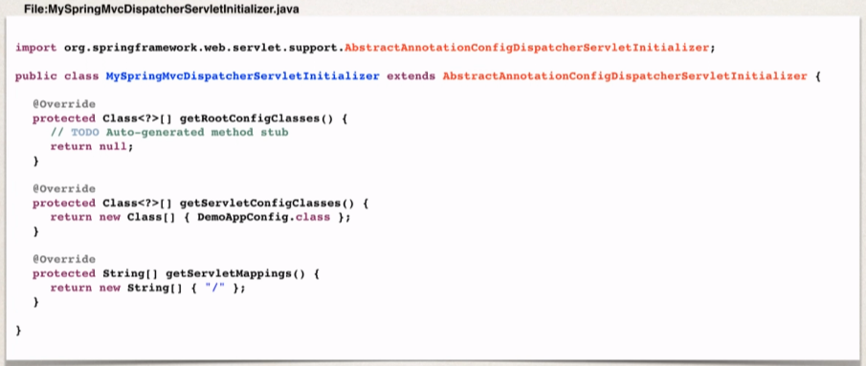

1. Create Spring REST Service using @RestController.

@RestController

@RequestMapping("/test")

**public** **class** DemoRestController {

@GetMapping("/hello")

**public** String sayHellow() {

**return** "Hello-world";

}

On starting the REST application, we get the 404 error page but we can directly go to the link;

[*http://localhost:8080/spring-rest-demo/test/hello*](http://localhost:8080/spring-rest-demo/test/hello)

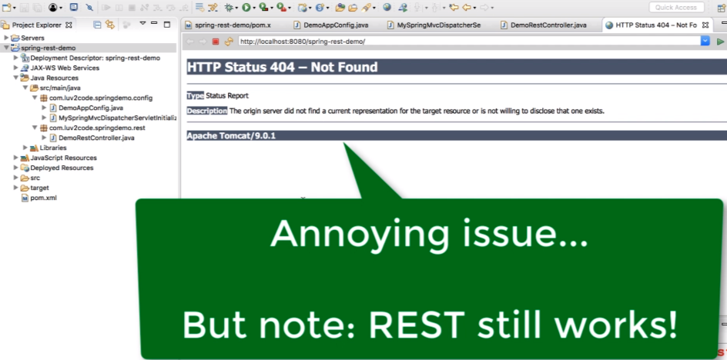But we can resolve this error:

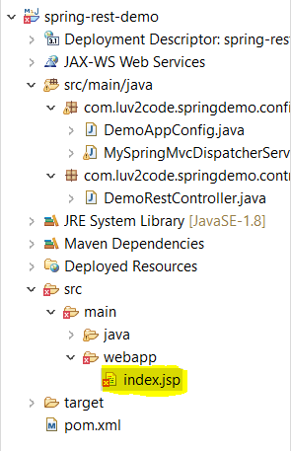Add an index.jsp page:

We will get to see some error, so clear those error we have to add the servlet jsp maven dependency.

<!-- Add support for jsp ... to get rid of Eclipse error -->

<dependency>

<groupId>javax.servlet.jsp</groupId>

<artifactId>javax.servlet.jsp-api</artifactId>

<version>2.3.1</version>

</dependency>

And then the error will be gone!

**File:** [**Index.jsp**](https://github.com/000GEV744/Spring-Git/blob/main/spring-rest-demo/src/main/webapp/index.jsp)

<html>

<body>

<h2>Spring REST Demo </h2>

<hr>

<a href=*"*${pageContext.request.contextPath }*/test/hello"*>Hello</a>

</body>

</html>

If we don’t want to give **“${pageContext.request.contextPath}”** the inside href provide the link without forward slash i.e., **“test/hello”.**

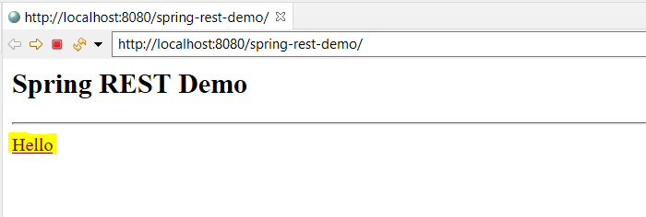

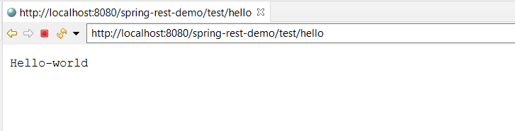**Click on Hello link:**



* 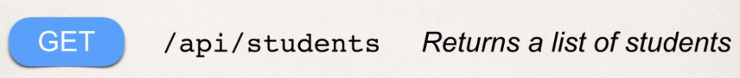**Retrieve POJOs as JSON:**

We are going to create REST Service for students.

**Convert Java POJO to JSON:**

* Our REST Service will return List<Student>
* Need to Convert List<Student> to JSON
* Jackson can help us out with this.

**Spring and Jackson support**

* Spring will automatically handle Jackson Integration
* As long as the Jackson project is on the classpath or pom.xml
* Then the JSON data being passed to the REST Controller is converted to Java POJO.
* Java POJO being returned from REST controller is converted to JSON.

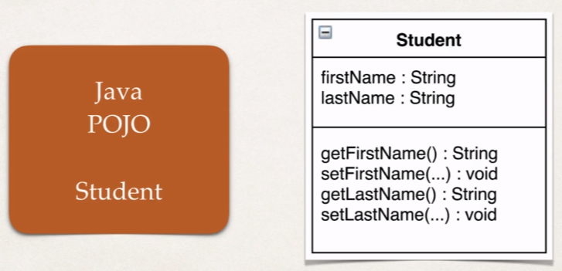

Jackson will call the appropriate getter / setter methods.

Development Process:

1. Create a Java POJO class for student. **File:** [Student.class](https://github.com/000GEV744/Spring-Git/blob/main/spring-rest-demo/src/main/java/com/luv2code/springdemo/entity/Student.java)
2. 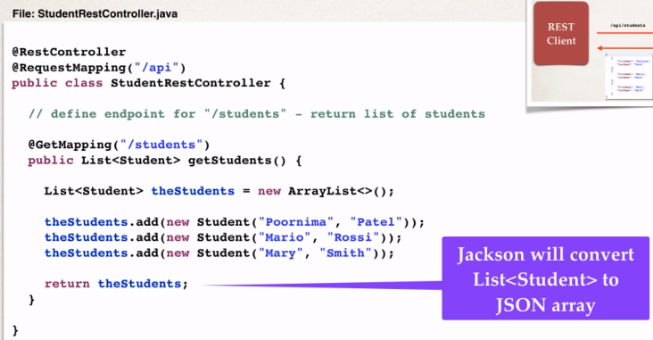Create @RestController.



**Spring REST with Path Variables:**

**Path variables:**

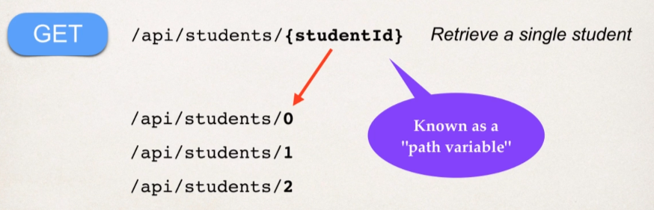Retrieve a single student by id:

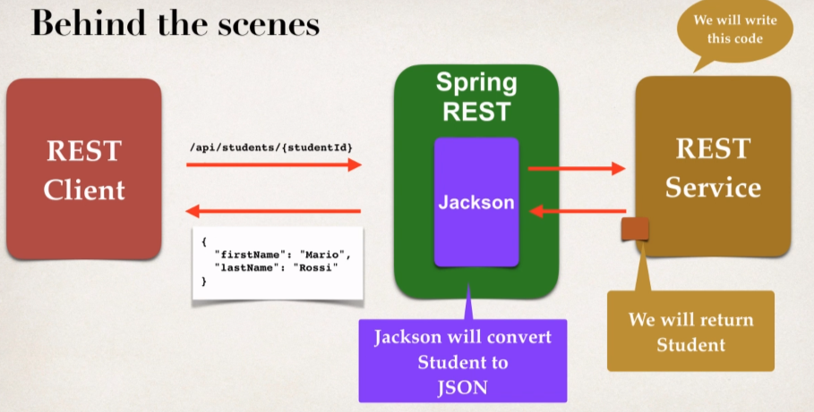

**Development Process:**

1. Add Request mapping to Spring REST service.
2. 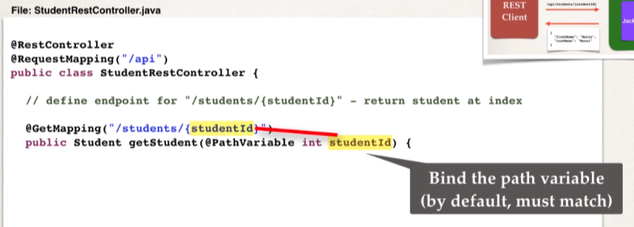Bind path variable to method parameter using **@PathVariable.**

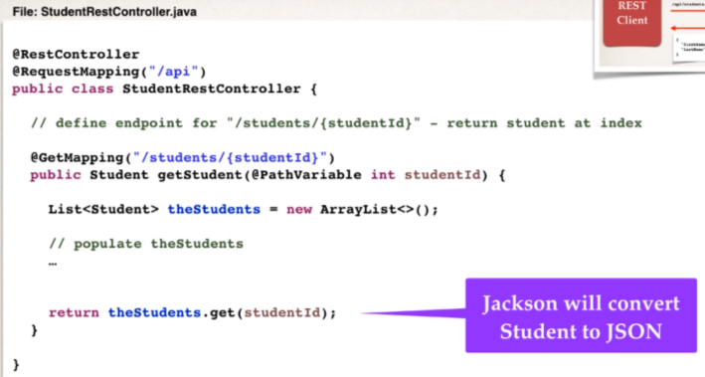

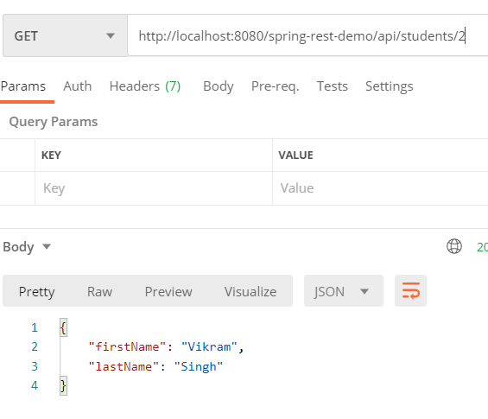Using the index, we will fetch the students:

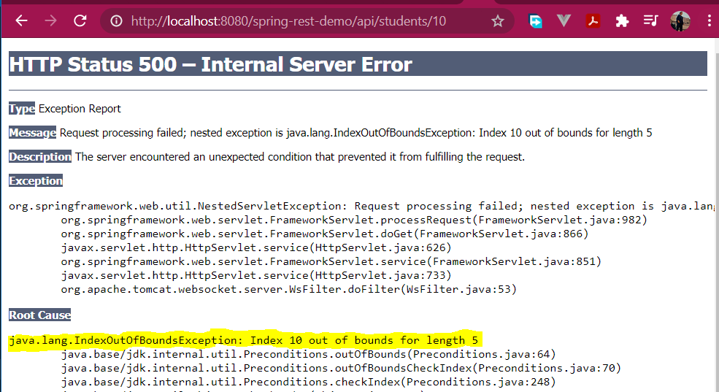But incase we send some out of bound index to the **pathVariable** then it will throw an exception:

So, we will the **exceptional handling** and the **status code**.



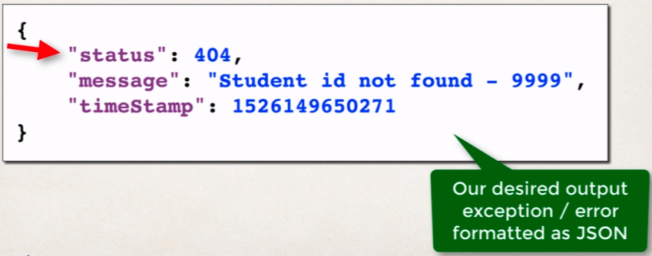So, we will handle the exception and return the JSON.

**Development Process:**

1. 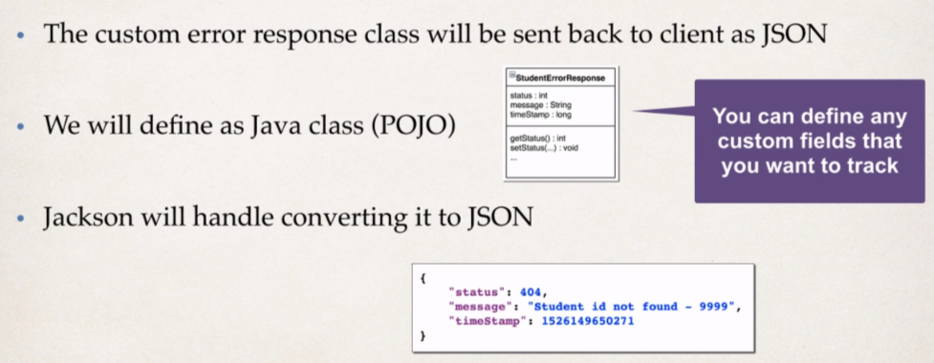Create a custom error response class.

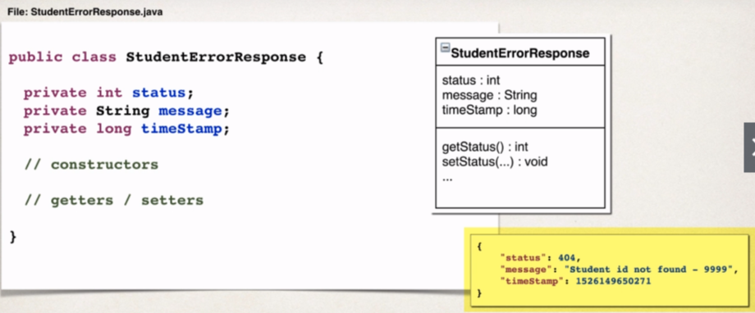

* The Customer Student exception will used by our REST service.
* In our code, if we can’t find student, then we will throw an exception.
* Need to define a custom student exception class (**StudentNotFoundException**)

1. 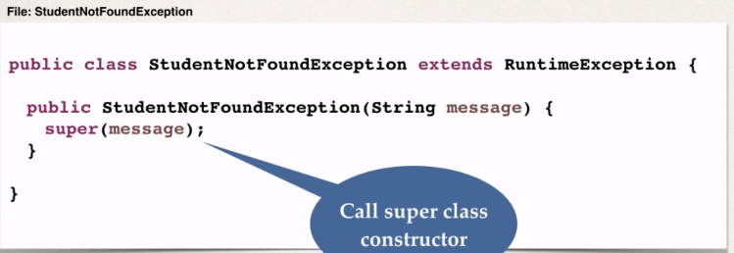Create a custom exception class.
2. Update REST service to throw exception if student not found

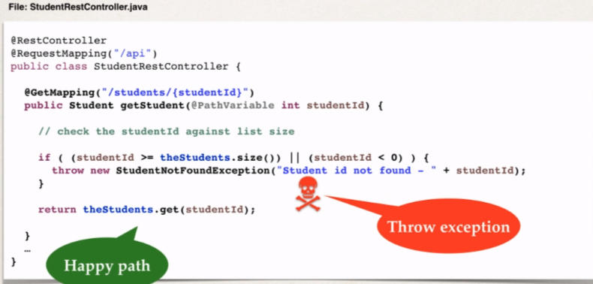

Now who is going to handle the exception and how do they give the appropriate exception back to the client.

1. Add an exception handler method using **@ExceptionHandler.**

* Define the exception handler method(s) with **@ExceptionHandler** annotation.
* Exception handler will return a **ResponseEntity**.
* **ResponseEntity** is a wrapper for the HTTP response object.
* **ResponseEntity** provides fine-grained control to specify:
* **HTTP** status code, HTTP headers and Response Body.

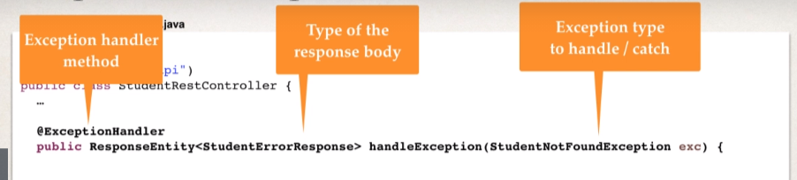

* With @ExceptionHandler we are saying hey this method that we are writing is an exception handler method.
* We also specify the type of the response body (i.e., **StudentErrorResponse** in our example case), so, this is the type of object that we will send back to the response body.
* 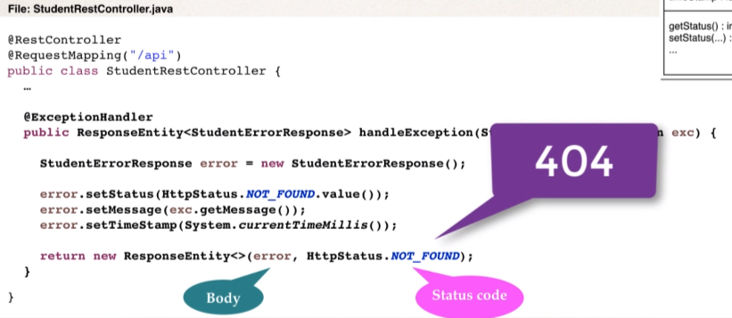Next, we are mentioning the type of exception that this Exception handler method is handling. (here in our example, it’s **StudentNotFoundException**). Then any **StudentNotFound** exceptions are thorwn then the exception handler method will catch it and work on it accordingly.

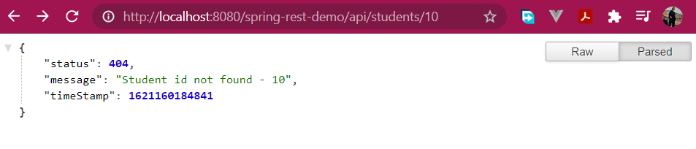**Response:**

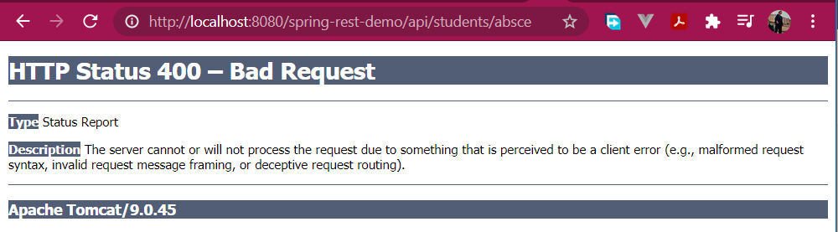But there is some edge case: what if we enter **string** instead of **int.**

**Console output:**

WARNING: Failed to bind request element: org.springframework.web.method.annotation.MethodArgumentTypeMismatchException: Failed to convert value of type 'java.lang.String' to required type 'int'; nested exception is java.lang.NumberFormatException: For input string: "absce"

So, we need to handle such edge cases as well, by modifying our exception handler.

**File**: StudentRestController.java

//add another exception handler ... to catch any exception

@ExceptionHandler

**public** ResponseEntity<StudentErrorResponse> handleException(Exception exc){

//create a studentErrorResponse

StudentErrorResponse error = **new** StudentErrorResponse();

error.setMessage(exc.getMessage());

error.setTimeStamp(System.*currentTimeMillis*());

error.setStatus(HttpStatus.***BAD_REQUEST***.value());

//return ResponseEntity

**return** **new** ResponseEntity<StudentErrorResponse>(error,HttpStatus.***BAD_REQUEST***);

}

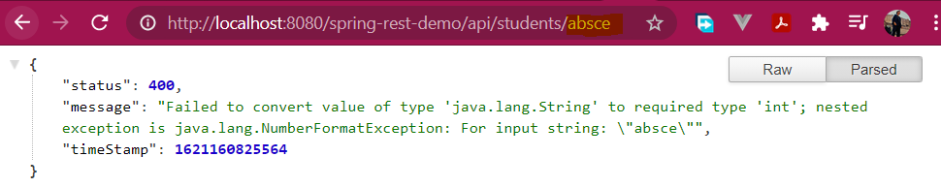**Response:**

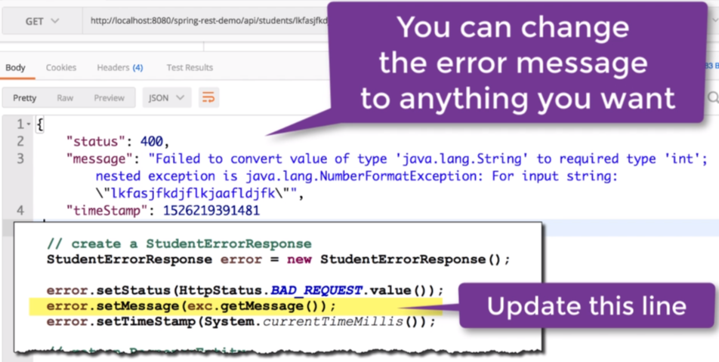

* 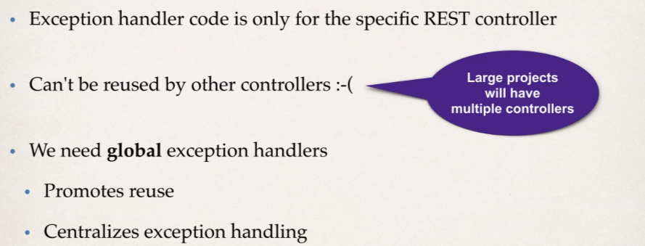**Spring REST - Global Exception Handling**

We will use Spring **@ControllerAdvice** annotation

* @ControllerAdvice is similar to an interceptor / filter.
* Pre-process requests to controllers.
* Post-process responses to handle exceptions.
* This is perfect for global exception handling.

And this is real time use of **Spring AOP**.

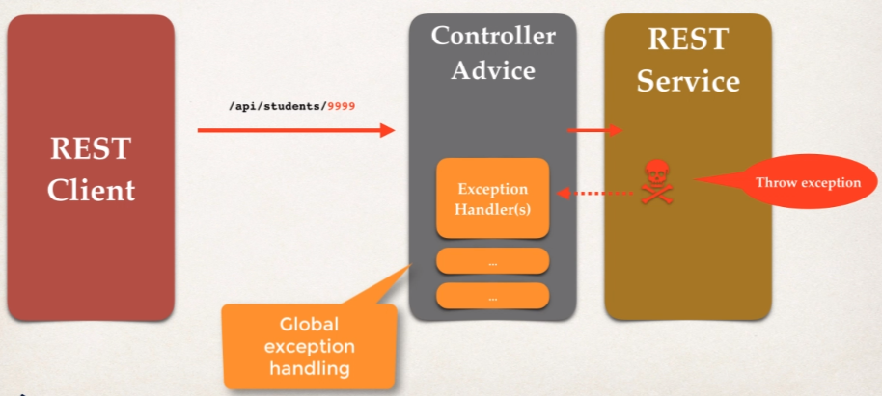

Now instead of exception handler being inside the REST Service, the exceptional handler is going to moved out and going to be moved out and place in the **ControllerAdvice**. And this will give support for Global Exception Handling.

**Development Process:**

* 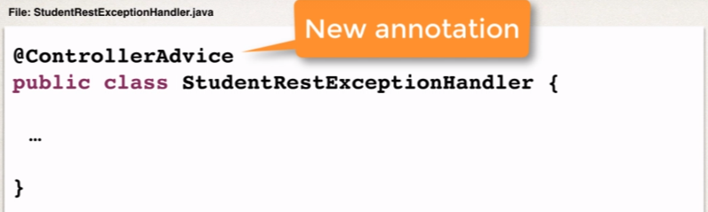Create a new @ControllerAdvice
* Refactor REST service …. Remove exception handling code from the Rest Controller class.
* 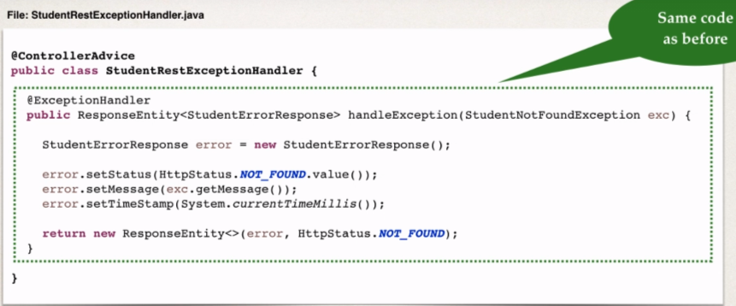Add exception handling code to @ControllerAdvcie.

**File:** StudentRestExceptionHandler.java

@ControllerAdvice

**public** **class** StudentRestExceptionHandler {

//add an excption handler using @Exception Handler

@ExceptionHandler

**public** ResponseEntity<StudentErrorResponse> handleException(StudentNotFoundException exc){

//create a studentErrorResponse

StudentErrorResponse error = **new** StudentErrorResponse();

error.setMessage(exc.getMessage());

error.setTimeStamp(System.*currentTimeMillis*());

error.setStatus(HttpStatus.***NOT_FOUND***.value());

//return ResponseEntity

**return** **new** ResponseEntity<StudentErrorResponse>(error,HttpStatus.***NOT_FOUND***);

}

//add another exception handler ... to catch any exception

@ExceptionHandler

**public** ResponseEntity<StudentErrorResponse> handleException(Exception exc){

//create a studentErrorResponse

StudentErrorResponse error = **new** StudentErrorResponse();

error.setMessage(exc.getMessage());

error.setTimeStamp(System.*currentTimeMillis*());

error.setStatus(HttpStatus.***BAD_REQUEST***.value());

//return ResponseEntity

**return** **new** ResponseEntity<StudentErrorResponse>(error,HttpStatus.***BAD_REQUEST***);

}

}

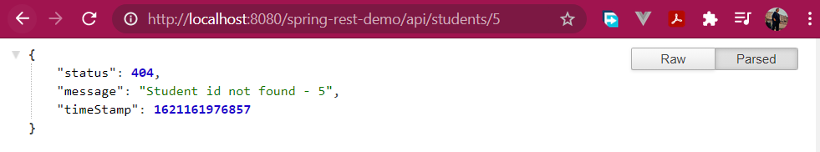**Response remains as it:**

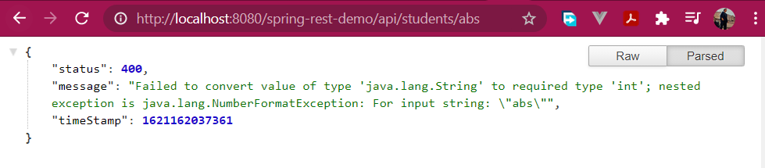



**REST API Design:**

API Design Process:

1. 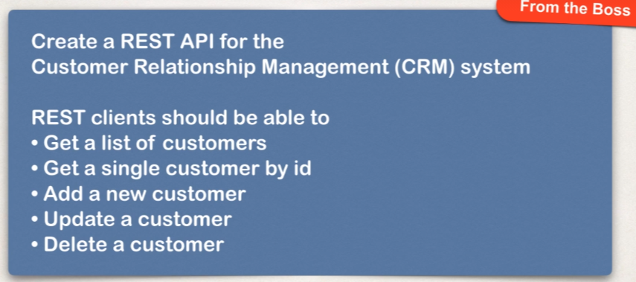Review API requirements
2. Identify main resource / entity

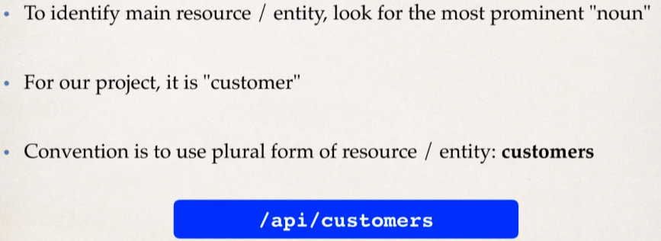

1. 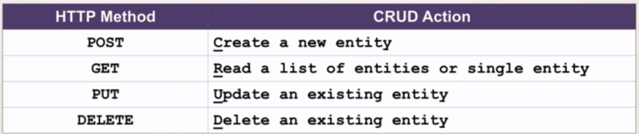Use HTTP methods to assign action on a given resource

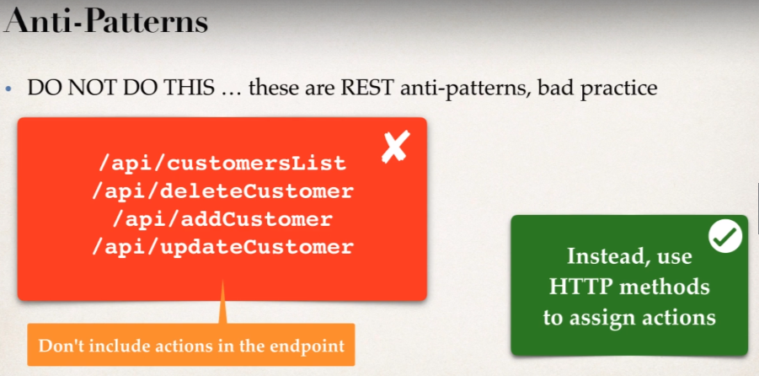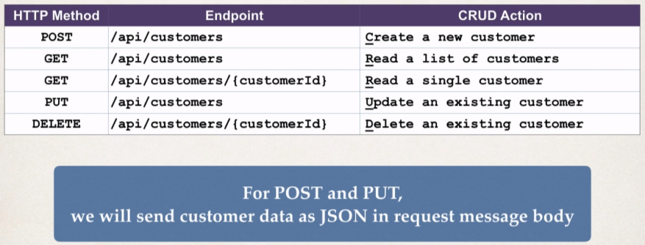

**NOTE: We should basically assign the actions based on the appropriate http methods.**

* 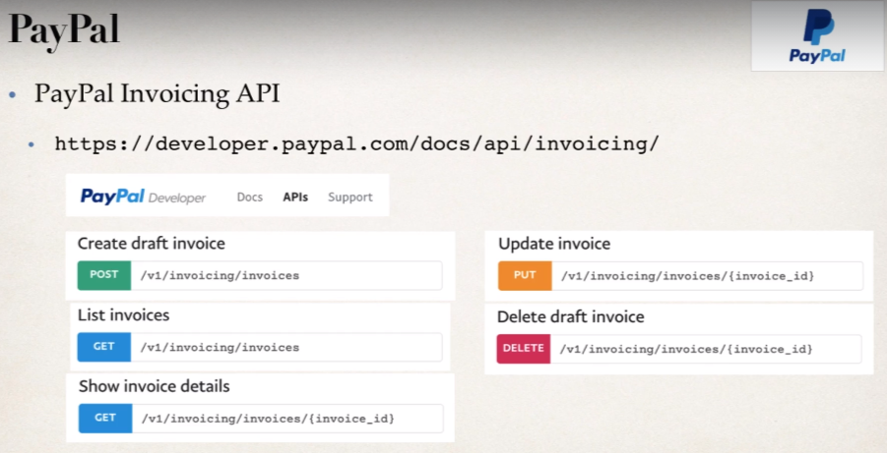**Some More examples from the real-time projects**

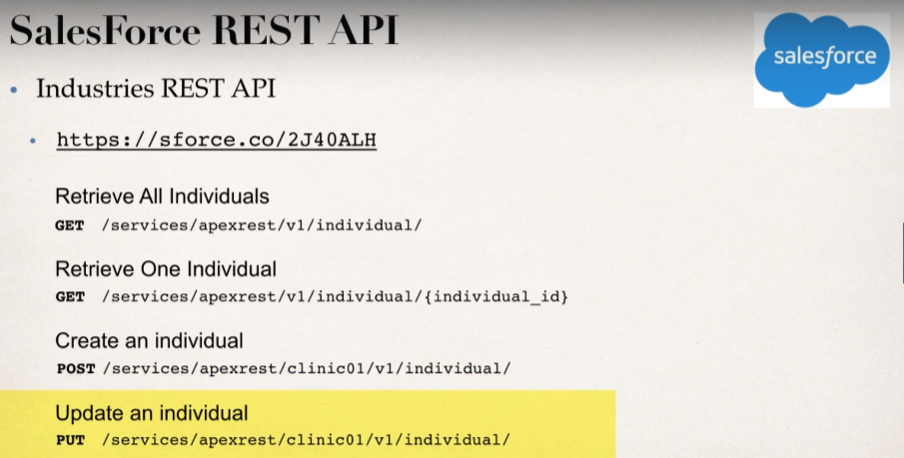

**Add Customer through Spring REST:**

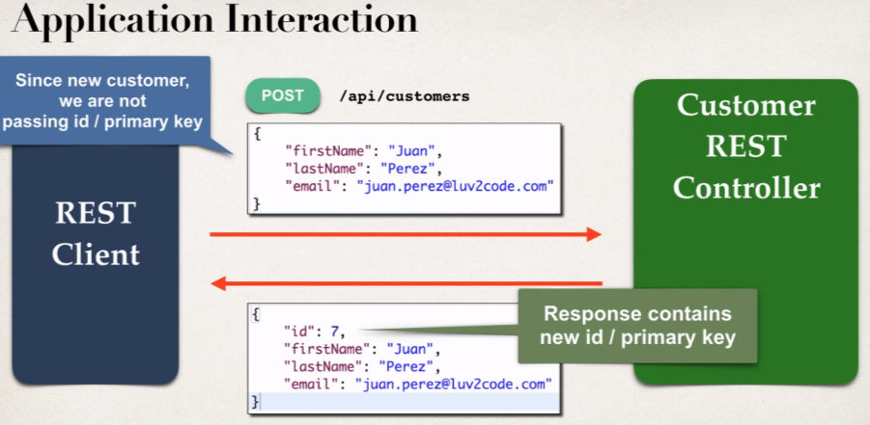Will cover POST method to create a customer or a new customer.

So, to access the request body, we will make use of Jackson:

* Jackson will convert the request body from JSON to POJO.
* 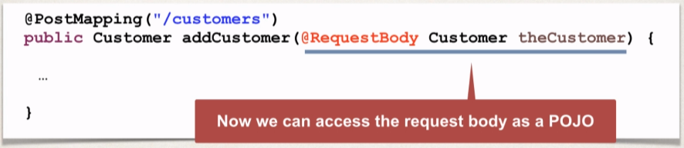**@RequestBody** annotation will bind the POJO to a method parameter.

Therefore, we use **@RequestBody** to access the request body as a POJO.

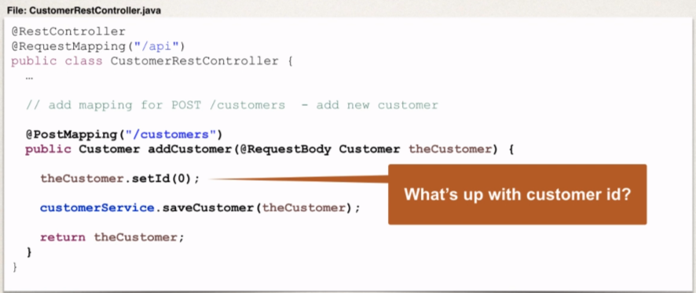

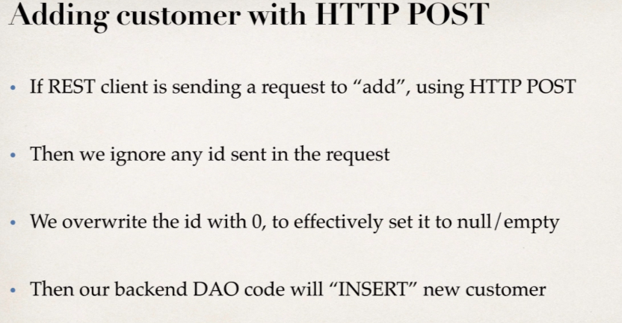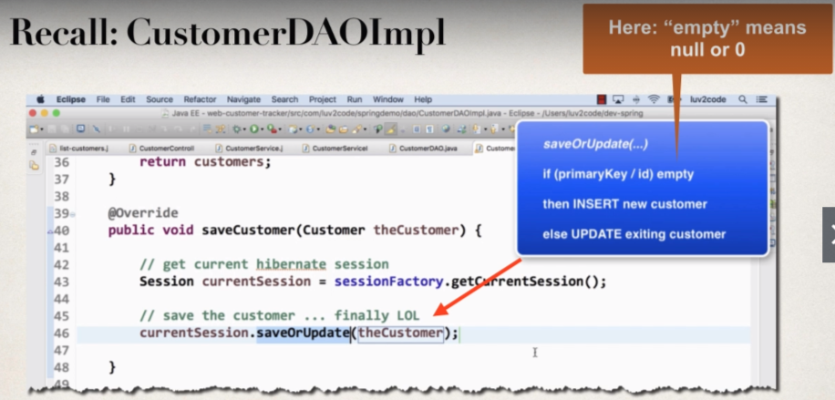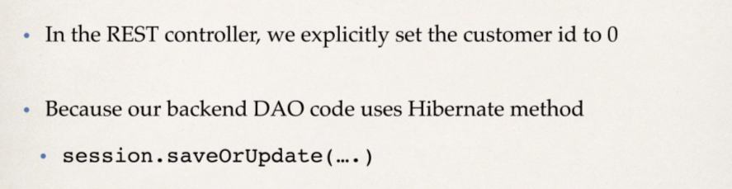**And why are we setting up the id as 0?**

